<http://hotrodsandbrakes.com/fordbrakekits.aspx>

55 - 57 FORD THUNDERBIRD & 54 – 56 FORD,MERCURY FB3FRONT DISC BRAKE KIT PARTS LIST

QTY DESCRIPTION PART NUMBER APPLICATION

1 CALIPER BRACKET LH

1 CALIPER BRACKET RH

2 SPINDLE BRACKET

2 BEARING SPACER

2 3/8 X 1 ½ GR 8 HHB

6 3/8 X 2 GR 8 HHB

2 3/8 HEX NUT

8 3/8 LOCK WASHER

2 1/2 X 2 1/4 GR 8 HHB

2 1/2 X 2 1/2 GR 8 HHB

4 1/2 HEX NUT

4 1/2 LOCK WASHER

2 * BRAKE ROTOR NAPA # 85564 (78 GRANADA)

2 * GREASE SEAL NAPA # 19221 (78 GRANADA)

2 * INNER BEARING NAPA # PBR13 (78 GRANADA)

2 * OUTER BEARING NAPA # PBR2 (64 GALAXIE)

2 * DUST CAP NAPA # 730-2436 (78 GRANADA)

1 * LH CALIPER NAPA # 242-2032 (80 MONTE CARLO)

1 * RH CALIPER NAPA # 242-2033 (80 MONTE CARLO)

4 * CALIPER BOLT NAPA # 82205 (80 MONTE CARLO)

1 * BRAKE PADS NAPA #TS-7070A-M (80 MONTE CARLO)

2 * BRAKE HOSE NAPA # 4136847 (80 MONTE CARLO)

CARQUEST #SBH 1015 (77-78 CAMARO)

2 * BANJO BOLT NAPA # 82743 (80 MONTE CARLO)

* NOT INCLUDED IN THE BUDGET KIT

SUGGESTED OPTIONAL PARTS NOT SUPPLIED IN KIT, OTHERS CAN BE

USED.

1 PROPORTIONING VALVE SPEEDWAY MOTORS # 910-31355

1 DUAL MASTER CYLINDER SPEEDWAY MOTORS # 910-31420

<http://www.speedwaymotors.com/Dual-Feed-Master-Cylinder,1985.html> Reman $36.99

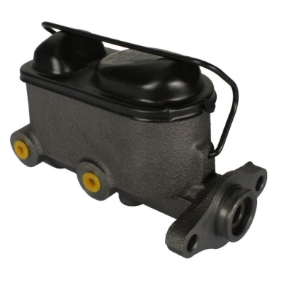

Factory rebuilt dual feed master cylinder with 2 bolt flange style mount. Use with Mr. Roadster Pedal Assemblies. This cylinder is similar to those used on mid-70's Fords (Mustang, Fairlane/LTD, etc. with disc front/drum rear).

Uses 3/8"-24 female inverted flare outlets. If plumbing with AN 3 lines, you will need two each 910318-3/8.

***Warning***: There is no longer a loop on the end of the push rod for this master cylinder. It is now threaded 3/8"-24 (fine) male. If you need a yoke for pedal hook-up, use 910-02973.

1. **Tech Tip:** The bigger the master cylinder is, the more fluid you get, but you'll have less pressure at the caliper.
2. ***Warning***: There is no longer a loop on the end of the push rod for this master cylinder. It is now threaded 3/8"-24 (fine) male. If you need a yoke for pedal hook-up, use 910-02973.
3. Bore Size:  1"
4. Mount Flange Bolt Pattern:  3.20" center-to-center
5. Mounting Bolt Holes:  3/8" or 10mm
6. 7 1/4" long without the pushrod, add 2" for the pushrod
7. 3" wide from the outside of the reservoir to the edge of the outlets
8. Mounting flange is 4" wide
9. Master cylinder is also 3-7/16" tall without a cap
10. Height with the cap clamped on is 5"
11. Push rod is threaded 3/8"-24 (fine thread). If you need a yoke for the pedal hook-up, use 910-02973

<http://www.speedwaymotors.com/Forged-Steel-Yoke-for-3-8-Inch-Rod,1539.html> $3.99 ea

The bolt pattern for attachment to a flange or bracket is 3.20" center to center for 3/8 " or 10mm bolts. This cylinder measures app.7"mount flange-to-front.

Speedway New 59.99

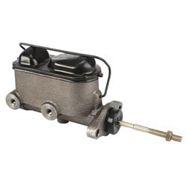

1968-1972 Mustang 1” bore

NAPA New MC 1929 $47.49

<http://www.napaonline.com/Catalog/CatalogItemDetail.aspx?A=NMAM1929_0358750733&An=599001+101969+50026+2026026+25003&Ar=AND(P_RecType%3aA)>

Right

Rock Auto New Bendix P/N 11378 $41.79

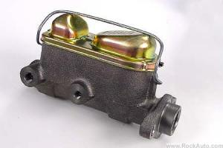

Speedway Combination Valve $59.99

<http://www.speedwaymotors.com/GM-Disc-Drum-Proportioning-Valve-for-3-8-24-Outlets,46424.html>

 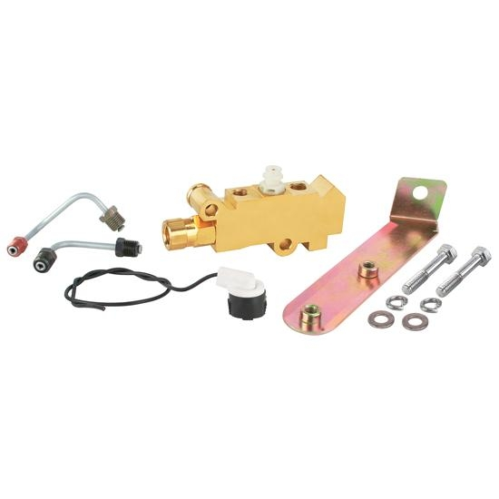

These proportioning valves are similar to what GM used on many cars in the 70's. They are non-adjustable and may require an adjustable valve in the rear brakes (if needed). Block incorporates metering (for front brakes) and proportioning (for rear brakes) into one unit. For use with front disc, rear drum brake systems.Includes hard lines to connect to a master cylinder with 3/8"-24 outlets.

Bottom Front Port: 3/8"-24 IFF threads - goes to one front brake  
Top Front Port: 3/8"-24 IFF threads - goes to one front brake  
Middle Top Port: 1/2"-20 IFF threads - comes from master cylinder  
Rear Top Port: 7/16"-24 IFF threads - comes from the master cylinder  
Rear Most Port: 9/16"-18 IFF threads - goes to rear brakes

"This valve is intended for vehicles having front DISC brakes and rear DRUM brakes. It includes hardlines that connect the proportioning valve to a master cylinder that has 3/8" outlets." ************************************** This is a 'combination' valve. It incorporates metering (for the front brakes) and proportioning (for the rear brakes)into one valve. This valve does *NOT* contain built in residual valves. ADDIT INFO: THE BOTTOM FRONT PORT HAS 3/8"-24 IFF THREADS AND GOES TO ONE FRONT BRAKE. THE TOP FRONT PORT HAS 3/8"-24 IFF THREADS AND GOES TO ONE FRONT BRAKE. THE MIDDLE TOP PORT HAS 1/2"-20 IFF THREADS AND COMES FROM THE MASTER CYLINDER. THE REAR TOP PORT HAS 7/16"-24 IFF THREADS AND COMES FROM THE MASTER

Link to Instructions for above MBM Combo Valve

<http://static.speedwaymotors.com/pdf/910-31351%20MBM%20prop%20valve.pdf>

CASCO Combination Valve $170.00

